Program Name 1:Program to Implement Audio and Video features of web page.
_________________________________________________________________________________
<!DOCTYPE html>
<html>
<head>
<title>Esport Music Playlist</title>
</head>
<body>
<center><h1 style="background-color:rgb(255, 99, 71);">ESPORT MUSIC PLAYLIST</h1></center>
<center>
<video width="640" height="480" controls>
<source src="theme.mp4" type="video/mp4">
<source src="theme.ogg" type="video/ogg">
Your browser does not support the video tag.
</video>
</center>
<ol>
<center>
<audio controls>
<source src="STARWALKING.ogg" type="audio/ogg">
<source src="STARWALKING.mp3" type="audio/mpeg">
Your browser does not support the audio tag.
</audio>
<audio controls>
<source src="Legend.ogg" type="audio/ogg">
<source src="Legend.mp3" type="audio/mpeg">
Your browser does not support the audio tag.
</audio>
</center>
</ol>
</body>
</html>
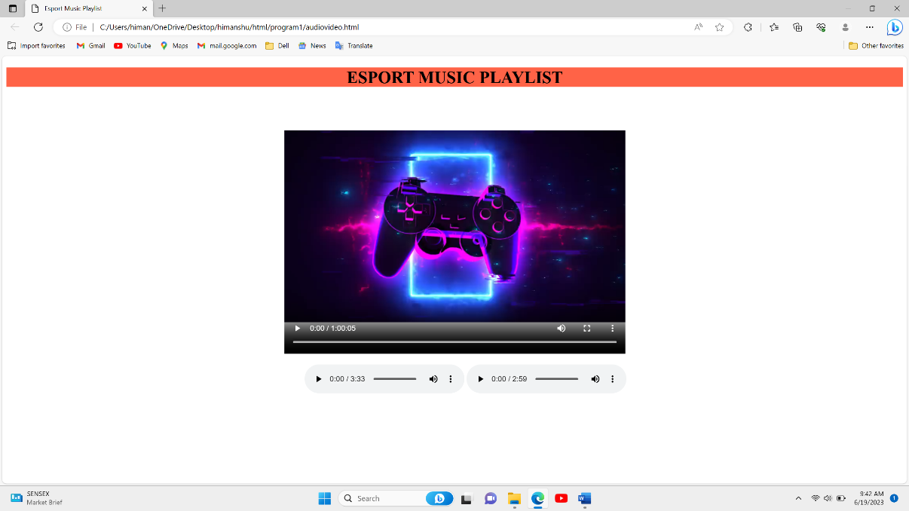
OUTPUT:

Program Name 2:Program to Design form using HTML5 elements, attributes and Semantics.
_________________________________________________________________________________
<!DOCTYPE html>
<html lang="en">

<head>
<title>Program 2</title>
</head>

<body>
<div>
<h1 style="text-align: center;">HTML5 Elements, AtributesAndSematics</h1>
<div style="display: flex;">
<div>
<h2>Sematics in HTML5</h2>
<header>
<h3>1.Header Section</h3>
<p>This is header section</p>
</header>
<h3>2.Nav tag</h3>
<nav>
<a href="#home">Home</a><br>
<a href="#about">About</a><br>
<a href="#contact">Contact</a>
</nav>
<h3>3. Section tag</h3>
<section>
<p>section 1</p>
</section>
<section>
<p>section 2</p>
</section>
<h3>4. Article</h3>
<article>
<h4>DevOps</h4>
<p style="width: 500px;">
DevOps is the combination of cultural philosophies, practices, and tools that increases an organization’s ability to deliver applications and services at high velocity: evolving and improving
products at a faster pace than organizations using traditional software development and infrastructure management processes. This speed enables organizations to better serve their customers and compete more effectively in the market.</p>
</article>
<h3>5. Aside</h3>
<aside>
<h4>Blockchain</h4>
<p style="width: 500px;">Blockchain technology is an advanced database mechanism that allows
transparent information sharing
within a business network. A blockchain database stores data in blocks that are linked together in a chain.</p>
</aside>
<h3>6.footer</h3>
<footer>
<p>Author: Abc</p>
<p><a href="abc@gmail.com">abc@gmail.com</a></p>
</footer>
</div>
<div>
<h2>HTML5 Elements AndAtributes</h2>
Input: <input type="email" name="email"><br>
Autocomplete: <input type="password" autocomplete="on"><br> Min And Max: <input type="text" min="10" max="10"><br>placholder: <input type="text" placeholder="This is placeholder"><br>
<p>Meter Tag: <meter min="0" value="239" max="296"></meter></p><div>progress: <progress value="70" max="100">70%</progress></p>svg<br>
<svg width="200" height="50">
<defs>
<linearGradient id="gradient" x1="0%" y1="0%" x2="100%" y2="0%">
<stop offset="0%" style="stop-color:rgb(255,255,255);stop-opacity:1.0" />
<stop offset="100%" style="stop-color:rgb(0,0,255);stop-opacity:0.75" />
</linearGradient>
</defs>
<rect x="10" y="10" width="160" height="100" style="fill:url(#gradient)">
</svg>
</div>
</div>

</div>
</div>
</body>
</html>

OUTPUT:
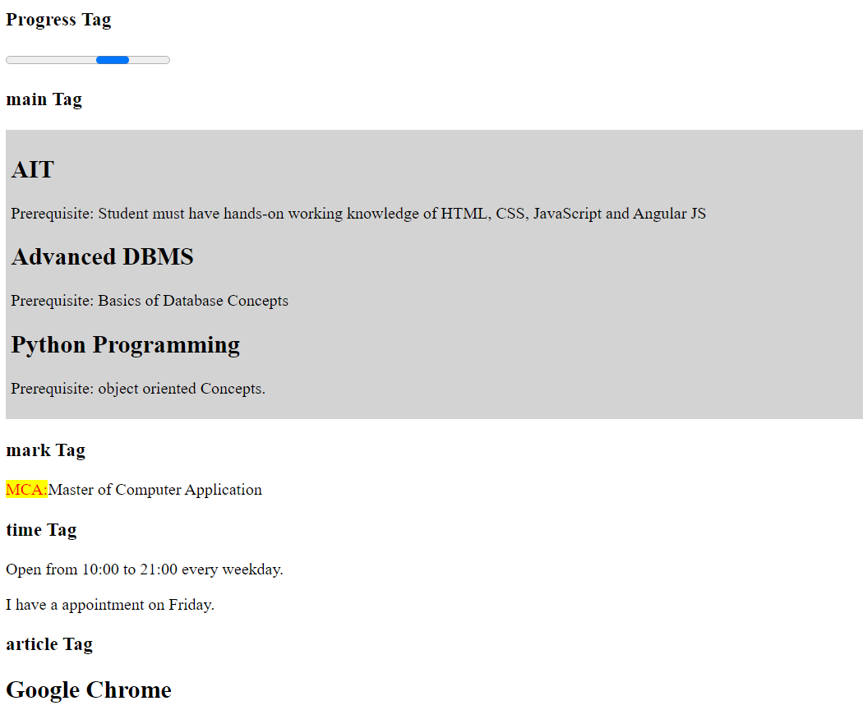

Program Name 3: Program using Canvas and SVG

a)Draw a text with Stroke Text () and draw Linear Gradient using canvas

<!DOCTYPE html>
<html lang="en">
<head>
<meta charset="UTF-8">
<meta http-equiv="X-UA-Compatible" content="IE=edge">
<meta name="viewport" content="width=device-width, initial-scale=1.0">
<title>Document</title>
</head>
<body>
<h1 style="color:rebeccapurple"> HTML </h1><h4> HTML canvas strokeText() Method </h4>
<canvas id="html" width="500" height="200">
</canvas>
<script> var c = document.getElementById("html"); var ctx = c.getContext("2d"); ctx.font = "60px Arial"; ctx.strokeStyle = "red"; ctx.strokeText("HTML", 50, 50); </script>
</body></html>

OUTPUT:
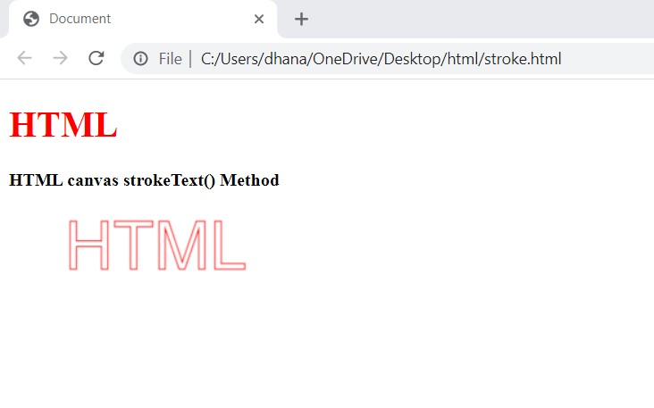

b)Draw rectangle, rounded triangle,circle,star using SVG graphics.
<!DOCTYPE html>
<html lang="en">
<head>
<title>Document</title>
<style>
.c {
position: absolute; left: 300px; top: 0px;
} .star {
position: absolute; left: 300px; top: 200px;
}
</style>
</head>
<body>
<div>
<h3>Rectangle:</h3>
<svg width="200" height="200">
<rect width="250" height="100" fill="GREEN" stroke="red" />
</svg>
</div>
<div>
<h3>Round Rectangle:</h3>
<svg width="500" height="200">
<rect x="70" y="20" rx="20" ry="20" width="210" height="140" style="fill:rgb(241, 11, 172);stroke:rgb(246, 19, 7);stroke-width:3;opacity:0.5" /></svg>
</div>
<div class="c">
<h3>Circle:</h3>
<svg width="200" height="200">
<circle cx="80" cy="80" r="50" fill="blue" stroke="red" />
</svg>
</div>
<div class="star">
<h3>Star:</h3>
<svg width="200" height="200">
<polygon points="100,9 50,200 180,75 10,75 160,200" style="fill:rgb(53, 175, 199);stroke:rgb(230, 84, 22);stroke-width:5;fill-rule:evenodd;" /></svg>
</div>
</body>
</html>

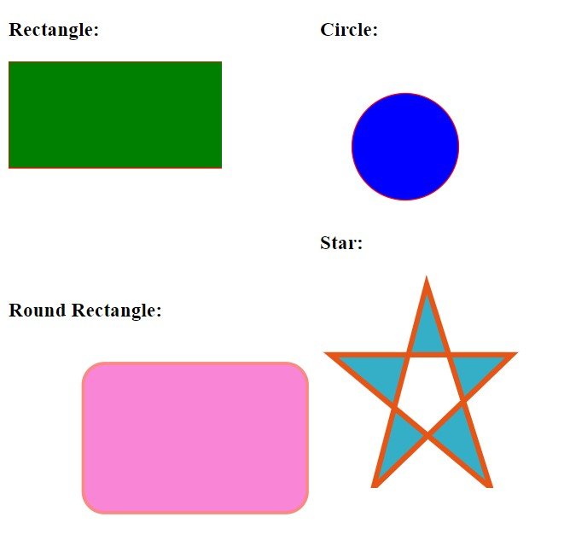
OUTPUT:

Program Name 4:Program to demonstrate external and Internal style in web page using font,text,background,borders,opacity and other CSS3 properties.
(Design Registration form)
___________________________________________________________________________
<html>
<head>
<title>Competition registration form</title>
<meta name="viewport" content="width=device-width, initial-scale=1">
<style>
body{
font-family:Arial;
background-color: antiquewhite;
}
* {
box-sizing:border-box;
}
.register{
padding: 18px;
background-color: aqua;
}
.buttonn:hover{
opacity: 1;
}
</style>
</head>
<body>
<form action="/action.html">
<div class="register">
<h1>Registration form</h1>
<h2>Please fill the form to register in various competition</h2>
<br>
<label for="Name"><b>Enter Your Name</label>
<input type="text" placeholder="Enter name" name="name" id="name" required><br><br>
<label for="college"><b>Enter your college name</label>
<input type="text" placeholder="enter college" name="college" id="college" required><br><br>
<label for="phone"><b>Enter your phone number</label>
<input type="tel" placeholder="phone" name="phone" id="phone" required><br><br>
<label for="email"><b>Enter your email</label>
<input type="text" placeholder="email" name="email" id="email" required><br><br>
<button type="submit"
class="buttonn">Register</button>
</form>
</body>
</html>

OUTPUT:
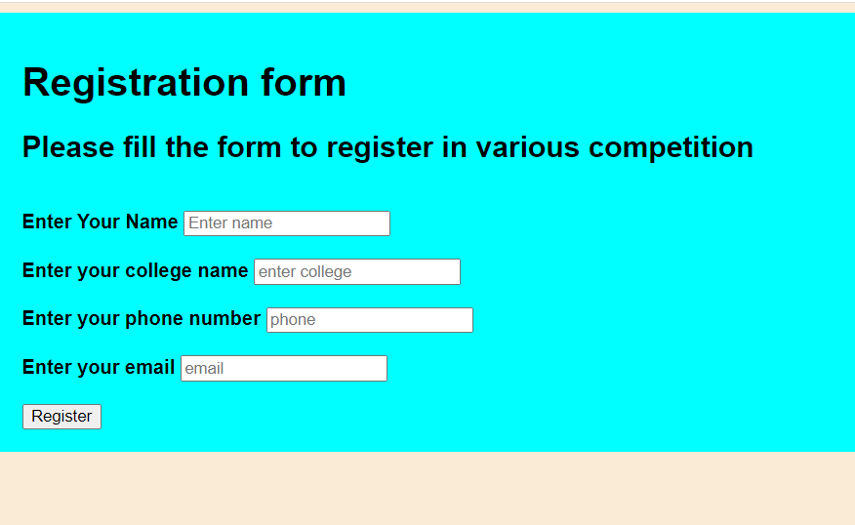
Program Name 5:Program to Implement Transformation using Translation, Rotation and Scaling in your web page.

<!DOCTYPE html>
<html lang="en">
<head>
<meta name="viewport" content="width=device-width, initial-scale=1.0">
<title>Document</title>
<style> .div { border: 1px black solid; text-align: center; height: 300px; width: 350px; margin: 70px; padding: 10px 20px;
} #t1 { color: blue; transform: rotate(50deg)
}
#t2 { transform: translate(50px, 20px); background-color: pink;
} #t3 { transform: scale(1.5); background-color: aqua;
}
</style>
</head>
<body>
<div class="div">
<h2 id="t1">Abhishek</h2>
<p>
<h2 id=tf2"> Abhishek </h2>
</p>
<br>
<h2 id="t3"> Abhishek </h2>
</div>
</body>
</html>
OUTPUT:
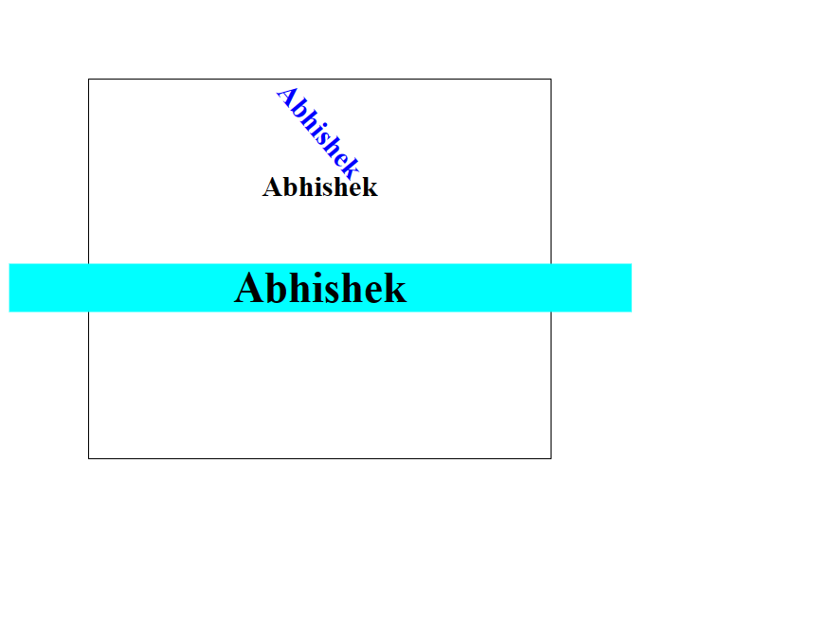

Program Name 6:Implement Transformation using Translation, Rotation and Scaling in your web page.

<!DOCTYPE html>
<html>
<head>
<title>Transformation Example</title>
<style>
#shape {
width: 100px;
height: 100px;
background-color: red;
position: absolute;
}
</style>
</head>
<body>
<div id="shape"></div>

<script>
// Translation
function translateShape(x, y) {
var shape = document.getElementById("shape");
shape.style.transform = "translate(" + x + "px, " + y + "px)";
}

// Rotation
function rotateShape(angle) {
var shape = document.getElementById("shape");
shape.style.transform = "rotate(" + angle + "deg)";
}

// Scaling
function scaleShape(scaleX, scaleY) {
var shape = document.getElementById("shape");
shape.style.transform = "scale(" + scaleX + ", " + scaleY + ")";
}

// Example usage
translateShape(100, 100);
rotateShape(45);
scaleShape(1.5, 1.5);
</script>
</body>
</html>

OutPut:

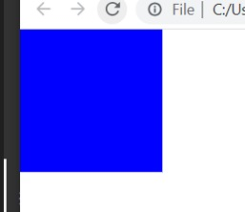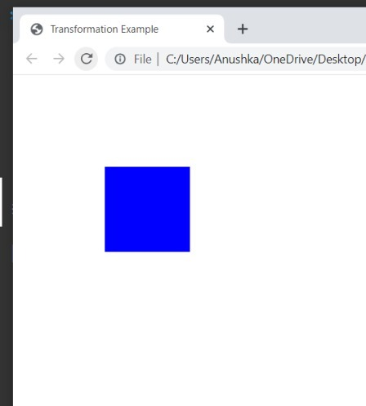

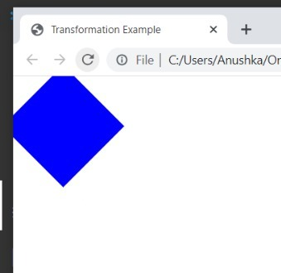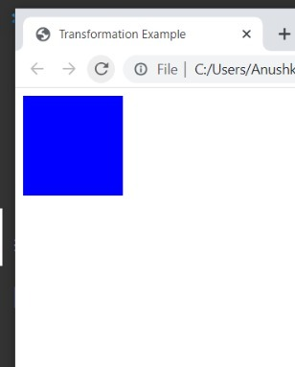

Program Name 7:Program to show current date and time using user defined module.

date_module.js

exports.getCurrentDateTime=function(){
const now=new Date();
return now.toISOString();

};

index.js

const datetime=require('./date_module');
const currentDateTime=datetime.getCurrentDateTime();
console.log("Current Date and Time="+currentDateTime);

Output:

PS C:\Users\USER\Desktop\AIT13\dateTime> node index.js
Current Date and Time=2023-06-16T04:01:41.525Z
PS C:\Users\USER\Desktop\AIT13\dateTime>

Program Name 8:Program using built-in modules to split the query string into readable parts.

index.js

constquerys=require('querystring');
constqueryString='name=Abhishe&age=23&city=Nagar';
constpq=querys.parse(queryString);
console.log(pq);

output :

PS C:\Users\USER\Desktop\AIT13\splitString> node index.js
[Object: null prototype] { name:’Abhishek’, age: '23', city: Nagar' }
PS C:\Users\USER\Desktop\AIT13\splitString>

Program Name 9:Program using NPM which will convert entered string into either case.

index.js

constconvertCase=require('js-convert-case');
process.stdout.write('Enter a String to Convert:');
process
.stdin.on('data',(data)=>{
const input=data.toString().trim();
const uppercase=input.toUpperCase();
const lowercase=input.toLowerCase();
console.log('Upper case:' +uppercase);
console.log('Lower case:' +lowercase);
process.exit();
});

OUTPUT:
Enter a String to Convert:anushka
Upper case:ANUSHKA
Lower case:anu
PS C:\Users\USER\Desktop\AIT13\eitherCase>

Program Name 10: Program to demonstrate the ngif, ngfor, ngswitch statements.

Index.html

<!-- app.component.html -->
<div *ngIf="showGreeting">
<h1>Welcome to my Angular app!</h1>
</div>
<ul>
<li *ngFor="let item of items">{{ item }}</li>
</ul>
<div [ngSwitch]="status">
<p *ngSwitchCase="'success'">Operation successful!</p>
<p *ngSwitchCase="'error'">An error occurred.</p>
<p *ngSwitchDefault>Unknown status.</p>
</div>

app.component.ts

// app.component.ts
import { Component } from '@angular/core';
@Component({
selector: 'app-root',
templateUrl: './app.component.html',
styleUrls: ['./app.component.css']
})
export class AppComponent {

showGreeting: boolean = true;
items: string[] = ['Item 1', 'Item 2', 'Item 3'];
status: string = 'success';
OUTPUT:
Welcome to my Angular app!

- Item 1
- Item 2
- Item 3
Operation successful!

11. Write PHP script to demonstrate Arrays in PHP.
Array.php
<?php
echo 'Index array'.'<br>';
$stud=array(1,'Gill','MCA','Sem1');
foreach ($stud as $k) { echo $k .'<br>'; }
echo 'associate array'.'<br>';
$stud_age=array("Gill"=>"21","Son"=>'32');
foreach ($stud_age as $k) { echo $k .'<br>'; }
// <!-- multidimensional array -->
echo 'multidimensional array'.'<br>';
$emp=array(
array(1,'son',2000000),
array(2,'Messi',20000000),
array(3,'libo',300000000),
);
for ($row = 0; $row <3; $row++) {
echo "Row number $row";
for ($col = 0; $col <3; $col++) {
echo $emp[$row][$col]."<br>";
}
// ?echo "</ul>";
}
?>

OUTPUT:
Index array
1
Gill
MCA
Sem1
associate array
21
32
multidimensional array
Row number 01
son
2000000
Row number 12
Messi
20000000
Row number 23
libo
300000000

Program Name 12: Write PHP Script to demonstrate different operators in PHP.
<?php
// error_reporting(0);
echo "Operators in PHP<br><br>";
echo "Arithmetic Operators:<br>
x=20 <br>
y=10<br>";
$x=20;
$y=10;
echo "Addition:x+y= ".$x+$y."<br>";`n
echo "Subtraction:x-y= ".$x-$y."<br>";
echo "Multiplication:x*y= ".$x*$y."<br>";
echo "Division:x/y= ".$x/$y."<br>";
echo "Moduls:x%y= ".$x%$y."<br>";
echo "Exponentiation:x**y= ".$x**$y."<br>";
echo "<br><br>";
echo "Assignment Operators:<br>
a=1<br>
b=2<br>";
$a=1.0;
$b=2.0;
echo "<br>";
echo "a=b a=: ".$a=$b;
echo "<br>";
echo "a+=b: ".$a+=$b;
echo "<br>";
echo "a-=b: ".$a-=$b;
59
echo "<br>";
echo "a*=b: ".$a*=$b;
echo "<br>";
echo "a/=b: ".$a/=4;
echo "<br>";
echo "a%=b: ".$a%=10;
echo "<br>";
echo "<br>";
echo "Comparison Operators:<br>
a1=10<br>
b1=10<br>";
$a1=10;
$b1=20;
echo "Equal($a1==$b1):";
var_dump($a1 == $b1);
echo "<br>";
echo "Identical($a1===$b1):";
var_dump($a1 === $b1);
echo "<br>";
echo "Not equal($a1!=$b1):";
var_dump($a1!=$b1);
echo "<br>";
echo "Not Identical($a1!==$b1):";
var_dump($a1!==$b1);
echo "<br>";
echo "Greater than($a1>$b1):";
var_dump($a1>$b1);
echo "<br>";
60
echo "Less than($a1<$b1):";
var_dump($a1<$b1);
echo "<br>";
echo " Greater than equal to($a1>=$b1):";
var_dump($a1>=$b1);
echo "<br>";
echo "Smaller than equal($a1<=$b1):";
var_dump($a1<=$b1);
echo "<br>";
echo "Spaceship($a<=>$b1):";
var_dump($a1<=>$b1);
echo "<br>";
echo "<br>";
echo "PHP Increment / Decrement Operators:<br>
m=1<br>
n=3<br>
j=3<br>
k=0<br>";
$m=1;
echo "Pre-increment: ++m: ".++$m;
echo "<br>";
$k=0;
echo "Post-increment: k++: ".$k++;
echo "<br>";
$n=3;
echo "Pre-decrement: --n: ".--$n;
echo "<br>";
$j=3;
61
echo "Post-decrement: j--: ".$j--;
echo "<br>";
echo "PHP Logical Operators:<br>";
$x=10;
$y=10;
echo" x and y: ";
echo $x and $y;
echo "<br>";
echo" x or y: ";
echo $x or $y;
echo "<br>";
echo" x && y: ";
echo $x && $y;
echo "<br>";
echo" x || y: ";
echo $x || $y;
echo "<br>";
echo "<br>";
echo "PHP String Operators<br>
str=hi<br>
str2=jay<br>";
$str1='hi';
$str2='jay';
echo "st1.str2 ".$str1.$str2;
echo "<br>";
echo "st1.=str2 ".$str2.=$str1;
echo "<br>";
?>
OUTPUT:
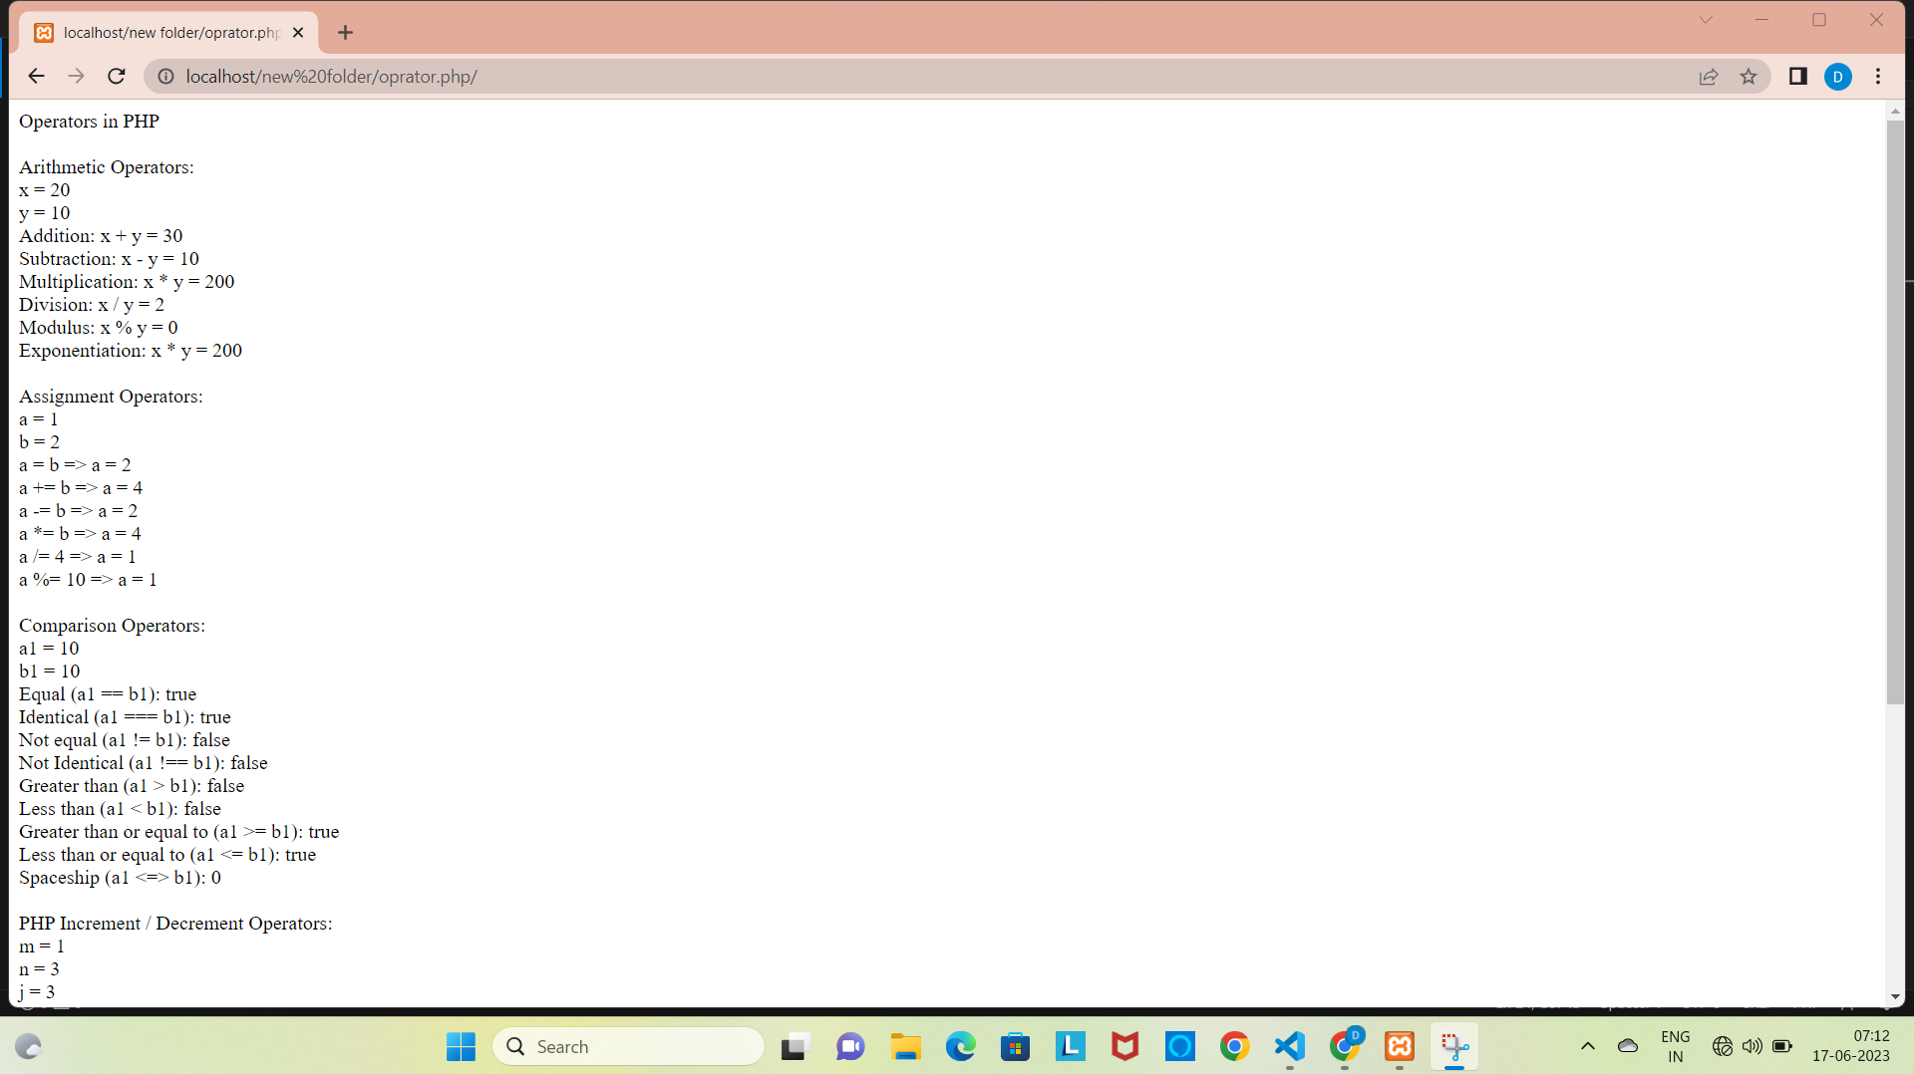

Program Name 13: Program to demonstrate session management using various techniques.

<?php
// Starting a session
session_start();
// Storing data in session variables
$_SESSION['username'] = Abhishek Chemate;
$_SESSION['email'] = 'abhishekchemate00@gmail.com';
// Accessing session data

$username = $_SESSION['username'];
$email = $_SESSION['email'];
// Displaying session data
echo "Username: " . $username . "<br>";
echo "Email: " . $email . "<br>";
// Modifying session data
$_SESSION['email'] = abhishekchemate00@gmail.com';
// Destroying a session
session_destroy();
?>

OUTPUT:

Username: Abhishek Chemate
Email: abhishekchemate00@gmail.com'

Program Name 14: Program to demonstrate Cookie management using various techniques.

Create/Retrieve a Cookie

<?php
$cookie_name = "user";
$cookie_value = "Abhishek";
setcookie($cookie_name, $cookie_value, time() + (86400 * 30));
?>
<html>
<body>
<?php

echo $_COOKIE[$cookie_name];

?>
</body>
</html>

Delete a Cookie

<?php
// set the expiration date to one hour ago

setcookie("user", "", time() - 3600);
?>
<html>
<body>
<?php
echo "Cookie 'user' is deleted.";
?>
</body>
</html>

OUTPUT:

Createcookie

Abhishek

delete cookie

cookie value:Abhishek
Warning: Undefined array key "user" in E:\xampp\htdocs\programs13\expirecookie.php on line 2
cookie value:

Program Name 15: Program to perform the CRUD Operations using PHP Script.

Connection.php
<?php

$con=mysqli_connect('localhost','root','tiger','mydb');
if(!$con){

die(mysqli_error($con));
echo" Connection not Successful";

}

?>

CURD

Insert values in database table

Insert.php

<?php
include "connection.php";
if (isset($_POST['firstname'])) {
$first_name = $_POST['firstname'];

$last_name = $_POST['lastname'];

$email = $_POST['email'];

$password = $_POST['password'];

$gender = $_POST['gender'];

$sql ="INSERT INTO `user`(`firstname`, `lastname`, `email`, `password`,
`gender`) VALUES
('$first_name','$last_name','$email','$password','$gender')";

$result = $con->query($sql);

if ($result == TRUE) {

echo "New record created successfully";

}else{

echo "Error:". $sql . "<br>". $con->error;

}

$con->close();

}

?>

<!DOCTYPE html>

<html>

<body>

<h2>Signup Form</h2>

<form action="" method="POST">
<fieldset>

<legend>Personal information:</legend>

First name:<br>

<input type="text" name="firstname">

<br>

Last name:<br>
<input type="text" name="lastname">

<br>

Email:<br>

<input type="email" name="email">

<br>

Password:<br>

<input type="password" name="password">

<br>

Gender:<br>

<input type="radio" name="gender" value="Male">Male

<input type="radio" name="gender" value="Female">Female

<br><br>

<input type="submit" name="submit" value="submit">

</fieldset>

</form>

</body>

</html>

Output:
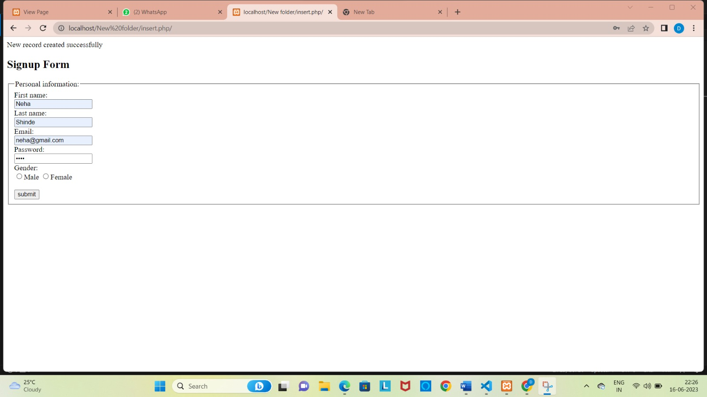

Read.php

<?php

include "connection.php";

$sql = "SELECT * FROM user";

$result = $con->query($sql);

?>

<!DOCTYPE html>

<html>

<head>

<title>View Page</title>

<link rel="stylesheet" href="https://maxcdn.bootstrapcdn.com/bootstrap/3.4.0/css/bootstrap.min.css">

</head>

<body>

<div class="container">

<h2>users</h2>

<table class="table">

<thead>

<tr>

<th>First Name</th>

<th>Last Name</th>

<th>Email</th>

<th>Gender</th>

<th>Action</th>

</tr>

</thead>

<tbody>

<?php

if ($result->num_rows> 0) {

while ($row = $result->fetch_assoc()) {

?>

<tr>

<td><?php echo $row['firstname']; ?></td>

<td><?php echo $row['lastname']; ?></td>

<td><?php echo $row['email']; ?></td>

<td><?php echo $row['gender']; ?></td>

<td><a class="btnbtn-info" href="">Edit</a>&nbsp;<a class="btnbtn-danger" href="">Delete</a></td>

</tr>

<?php }

}

?>

</tbody>

</table>

</div>

</body>

</html>

Output:
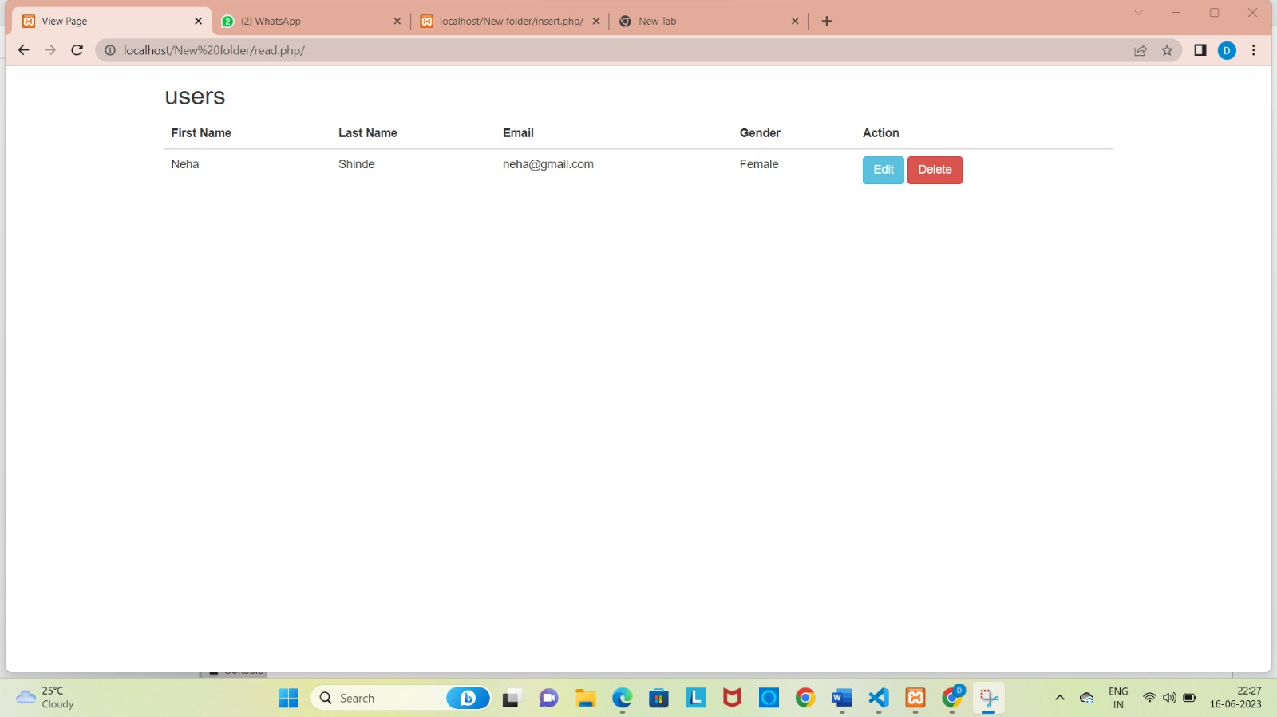

Update.php

<?php

include "connection.php";

if (isset($_POST['update'])) {

$firstname = $_POST['firstname'];

$user_id = $_POST['user_id'];

$lastname = $_POST['lastname'];

$email = $_POST['email'];

$password = $_POST['password'];

$gender = $_POST['gender'];

$sql = "UPDATE `user` SET `firstname`='$firstname',`lastname`='$lastname',`email`='$email',`password`='$password',`gender`='$gender' WHERE `id`='$user_id'";

$result = $con->query($sql);

if ($result == TRUE) {

echo "Record updated successfully.";

}else{

echo "Error:" . $sql . "<br>" . $con->error;

}

}

if (isset($_GET['id'])) {

$user_id = $_GET['id'];

$sql = "SELECT * FROM `users` WHERE `id`='$user_id'";

$result = $con->query($sql);

if ($result->num_rows> 0) {

while ($row = $result->fetch_assoc()) {

$first_name = $row['firstname'];

$lastname = $row['lastname'];

$email = $row['email'];

$password = $row['password'];

$gender = $row['gender'];

$id = $row['id'];

}

?>

<h2>User Update Form</h2>

<form action="" method="post">

<fieldset>

<legend>Personal information:</legend>

First name:<br>

<input type="text" name="firstname" value="<?php echo $first_name; ?>">

<input type="hidden" name="user_id" value="<?php echo $id; ?>">

<br>

Last name:<br>

<input type="text" name="lastname" value="<?php echo $lastname; ?>">

<br>

Email:<br>

<input type="email" name="email" value="<?php echo $email; ?>">

<br>

Password:<br>

<input type="password" name="password" value="<?php echo $password; ?>">

<br>

Gender:<br>

<input type="radio" name="gender" value="Male" <?phpif($gender == 'Male'){ echo "checked";} ?>>Male

<input type="radio" name="gender" value="Female" <?phpif($gender == 'Female'){ echo "checked";} ?>>Female

<br><br>

<input type="submit" value="Update" name="update">

</fieldset>

</form>

</body>

</html>

<?php

} else{

header('Location: view.php');

}

}

?>

OutPut:
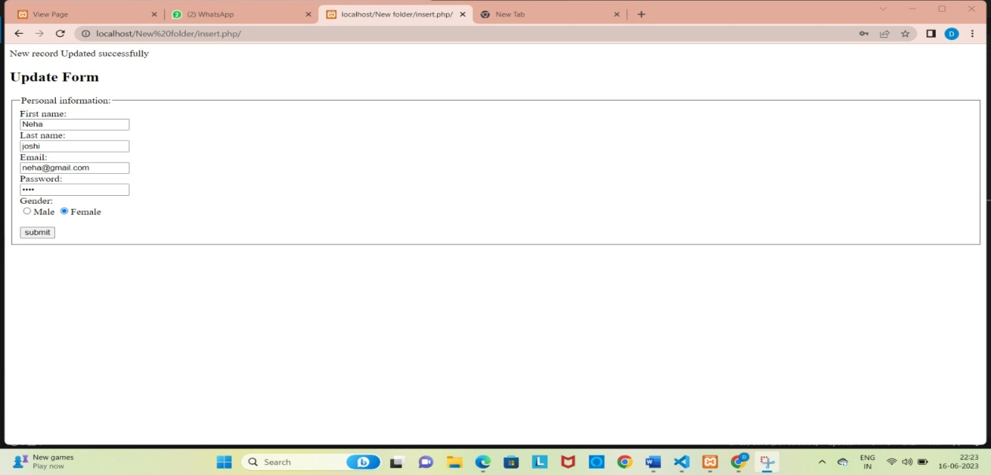
Delete Form:

<?php

include "connection.php";

if (isset($_GET['id'])) {

$user_id = $_GET['id'];

$sql = "DELETE FROM `user` WHERE `id`='$user_id'";

$result = $con->query($sql);

if ($result == TRUE) {

echo "Record deleted successfully.";

}else{

echo "Error:" . $sql . "<br>" . $con->error;

}

}

?>

Output:
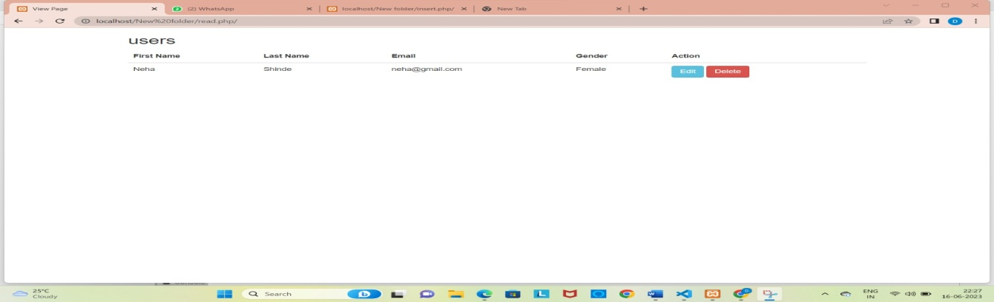

Program Name 16: Write a PHP program to fill an online form for AADHAR card registration (Design registration form with suitable fields) and insert into the database. Write PHP script to display details on different pages using $_GET and $_POST

AdharCard_post.html
<!DOCTYPE html>
<html lang="en">
<head>
<meta charset="UTF-8">
<meta http-equiv="X-UA-Compatible" content="IE=edge">
<meta name="viewport" content="width=device-width, initial-scale=1.0">
<title>Aadhar Card Registration!!</title>
</head>
<style> .container{ border: 2px solid black; padding: 20px; margin: auto 35%;
align-content: center;
}
</style>
<body>
<div class="container">
Using Post method: <br>
<form action="aadharcard_action_post.php" method="post">
Full Name:<br><input type="text" name="fullname"><br><br>
TIN(TaxPayer Identification Number):<br><input type="number" name="tin"><br><br>
43
Enter Emailid: <br><input type="text" name="emailid"><br><br>
Mobile Number: <br>
<input type="number" name="mobile_no"><br><br>
Gender: <br>
Male:<input type="radio" name="gender" value="male"><br>
Female:<input type="radio" name="gender" value="female"><br><br>
Date of Birth: <br><input type="date" name="dob"><br><br><br>
Address: <br>
<textarea name="address" cols="30" rows="5"></textarea><br><br>
<button type="submit">Register</button>
<button type="reset">Cancel</button>
</form>
</div>
</body>
</html>
Output:

Aadharcard_action.php
<?php
error_reporting(0);
$pid=$_REQUEST['pid'];
$fullname=$_REQUEST['fullname'];
$tin=$_REQUEST['tin'];
$emailid=$_REQUEST['emailid'];
$gender=$_REQUEST['gender'];
$dob=$_REQUEST['dob'];
$mobileno=$_REQUEST['mobile_no'];
$address=$_REQUEST['address'];
/44
$con=mysqli_connect("localhost","root","tiger","mydb");
if ($con==true) { echo "Database Connected Successfully!!<br>";
} else{ echo "Failed!"; }
//insert Data
// $mysql="INSERT INTO aadharcard_reg
values('$pid','$fullname','$tin','$emailid','$mobile_no','$gender','$dob','$address' )";
?>
<!DOCTYPE html>
<html>
<head>
<meta charset="utf-8">
<meta name="viewport" content="width=device-width, initial-scale=1">
<title></title>
</head>
<body>
Hi!,<?php echo $_POST['fullname']; ?> You have Successfully
CompeletedRegisration Process!!! <br>
Your Email ID: <?php echo $_POST['emailid']; ?>You will recevied an email about aadharCard!!
</body>
</html>
OutPut:

